|  |  |  |  |  |  |  |
| --- | --- | --- | --- | --- | --- | --- |
| ID | Name | Description | Expected Result | Actual Result | Fix | Proof |
| T001 | The game can boot | Checking to see if the game can boot from the build. | The game should open just fine and open on the main menu. | As Expected |  | T001 |
| T002 | Connect time out | Check to see if timing out works. | Connect to a dud endpoint / IP and see after 30 seconds you get timed out and a message is on screen. | As Expected |  | T002 |
| T003 | Hosting | Check to see if you can host. | Click host game and click host, you should then start and load into the server. | As Expected |  | T003 |
| T004 | Joining | Check to see if you can join. | Click join game and then click join, you should be attempting to connect but then load into the server. | As Expected |  | T004 |
| T005 | Max player count limit | Check to see if you get kicked. | Join the server with two other accounts playing and see if the server will kick you. | Mostly Expected | Error message is wrong. | T005 |
| T006 | Client disconnects | The client disconnecting from lobby. | You should be taken to the main menu and leave the server. | As Expected |  | T006 |
| T007 | Host disconnects | The host disconnecting with the server. | You should be taken to the main menu and leave the server and others should be kicked. | As Expected |  | T007 |
| T008 | Fore start | Force starting the game. | Only the host should be able to force start the server and the game should start. | As Expected |  | T008 |
| T009 | Auto start | Waiting for auto start. | Let the timer tick down to see if the server will auto start the round. | As Expected |  | T009 |
| T010 | Loading into the round. | Loading into the round of the game. | You and the other player should be loaded into the game. Full HP, 90 reserve ammo with 30 in the mag and 2 cs grenades. | As Expected |  | T010 |
| T011 | Player movement | Player moving around and syncing on the client’s screen. | Move around and jump too and see if it’s replicated on the clients’ screen. Animations should sync too. | Walking around works but jumping is very unresponsive at times.  Animations sync though. | Jumping is not responsive enough, need to spam space to jump. | T011 |
| T012 | Firing weapon. | Testing weapon combat. | Should deal damage to the other player and instant kill in the head.  Weapon cannot fire with no ammo. | Shooting works, but the player keeps hitting themselves.  Instant kill and damage works against other players. | Firing the weapon, the player can hit themselves. | T012 |
| T013 | CS Grenade | The gas grenade | Test throwing it, pressing G and holding it for a second.  Test the gas does tick damage, reduces sight and muffles audio when touch. And it lingers after leaving. | As Expected |  | T013 |
| T014 | Collectables spawning |  | See if collectables spawn a maximum of 4 present on the world, once one goes, another can spawn.  Check to see if its random spawns and collectable types. | As Expected |  | T014 |
| T015 | Collectables | Testing collectables | Test if you can pick up and collect all 4 collectables.  Ammo, double damage,  Grenade bonus and health. | Ammo give ammo the mag and not the pool.  Health works.  Double damage works.  Cs Gas works. | Ammo is given into the mag and not the pool. | T015 |
| T016 | Pressing ESC in game will close the game |  | ESC in the game will close it. (only while in the game / server). | As Expected |  | T016 |
| T017 | In game UI |  | Player health, damage indicator, gas indicator, ammo indicator, grenade count indicator.  Timer indicator, ping indicator, fps indicator.  Current round and score indicator (only in pregame). | As Expected |  | T017 |
| T018 | Bonus |  | Round timer runs out, person with highest health wins or no one wins. | Wrong person wins | The person with the lowest health wins instead of the highest. | T018 |
| T019 |  |  |  |  |  |  |
| T020 |  |  |  |  |  |  |
| T021 |  |  |  |  |  |  |
| T022 |  |  |  |  |  |  |
| T023 |  |  |  |  |  |  |
| T024 |  |  |  |  |  |  |
| T025 |  |  |  |  |  |  |
| T026 |  |  |  |  |  |  |
| T027 |  |  |  |  |  |  |
| T028 |  |  |  |  |  |  |
| T029 |  |  |  |  |  |  |
| T030 |  |  |  |  |  |  |
| T031 |  |  |  |  |  |  |
|  |  |  |  |  |  |  |
|  |  |  |  |  |  |  |

# T001:

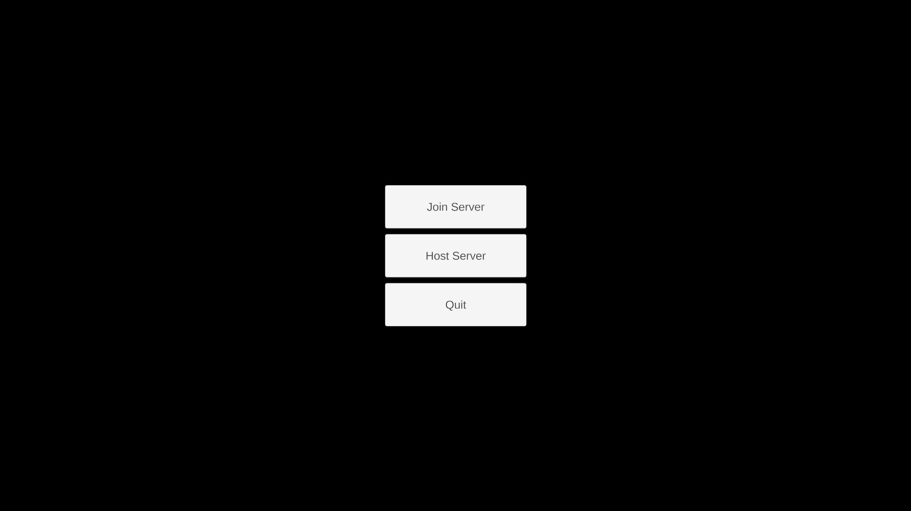

# T002:

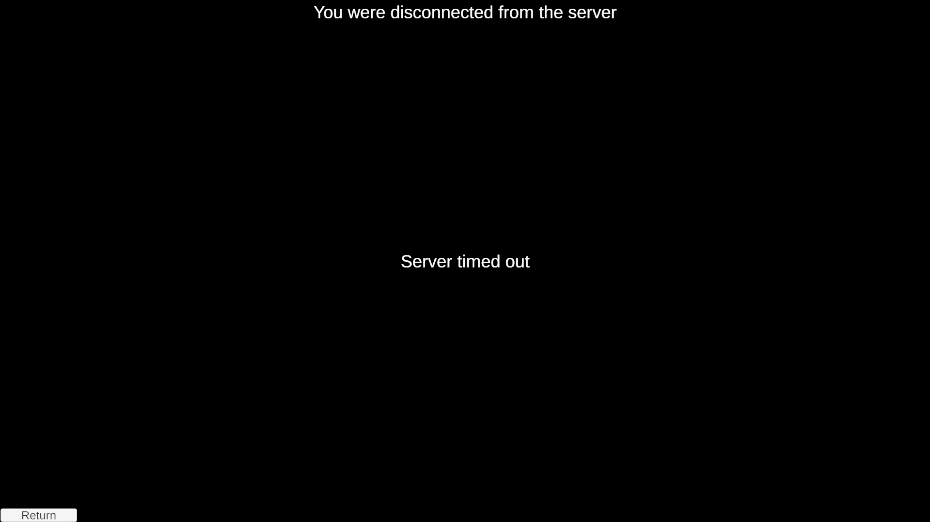

# T003:

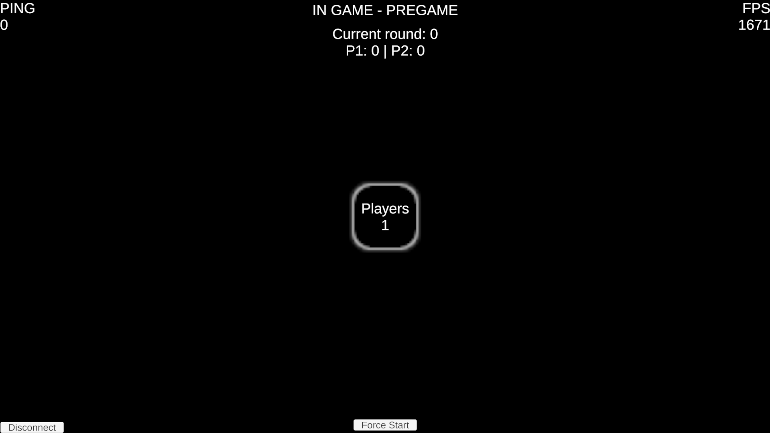

# T004:

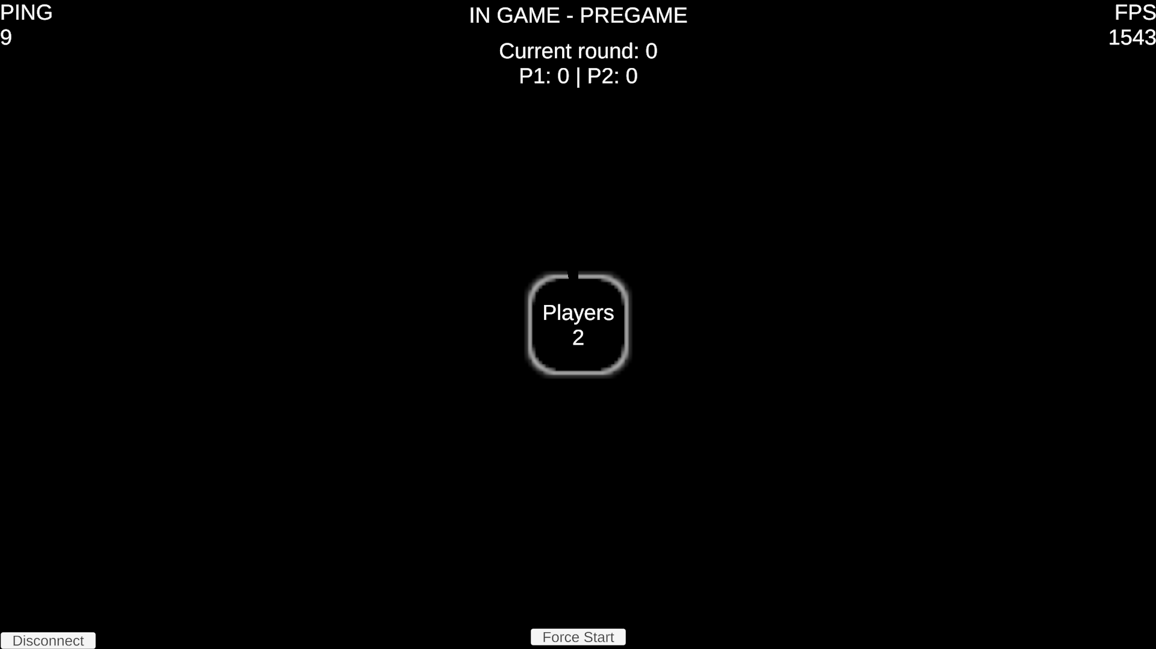

# T005:



# T006:



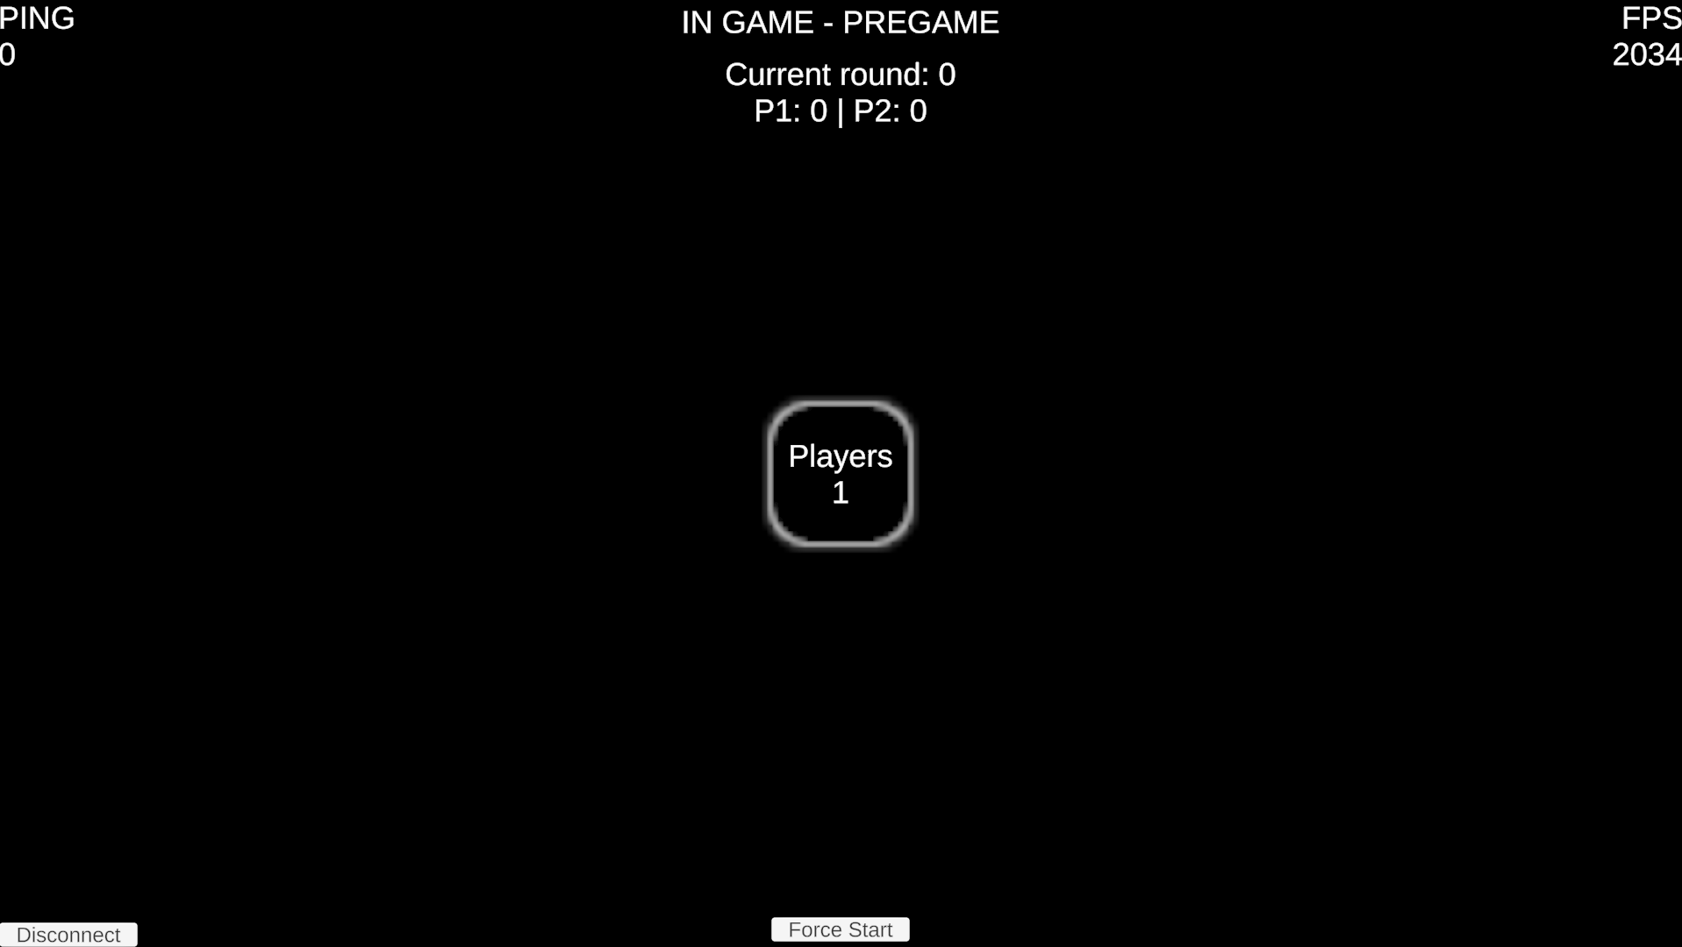

# T007:



# T008:



# T009:



# T010:

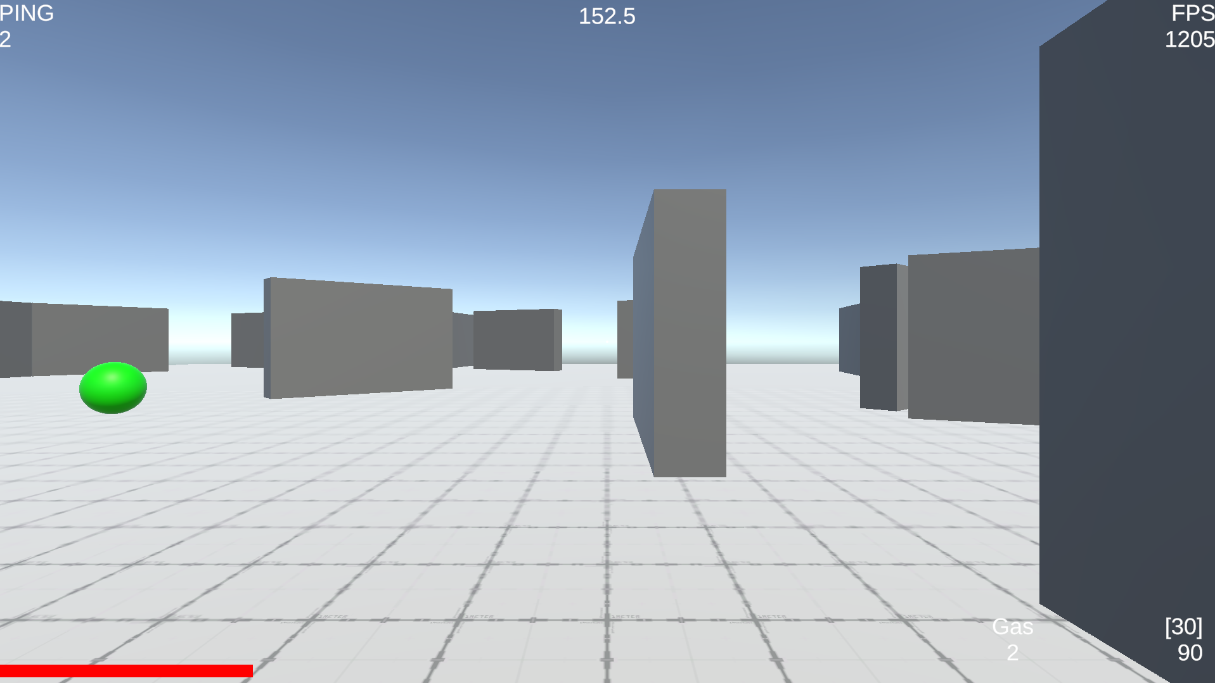

# T011:



# T012:



# T013:



# T014:



# T015:



# T016:



# T017:

# T018:

